Procedure To Extend LVM root Partition in CentOS 6

Step1: Shutdown the VM that you want to increase the partition.

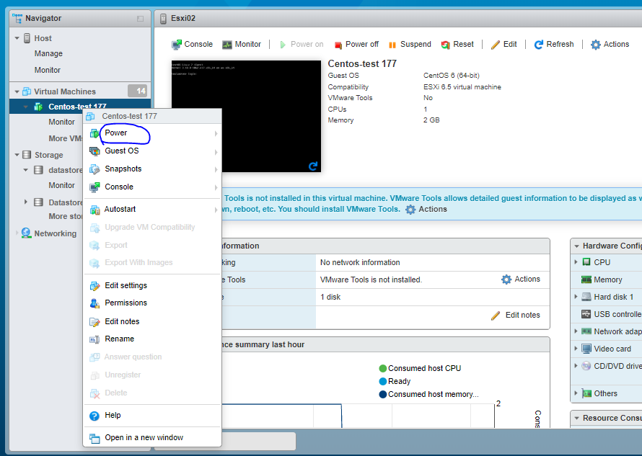

Step2: Extend the partition as per your choice.

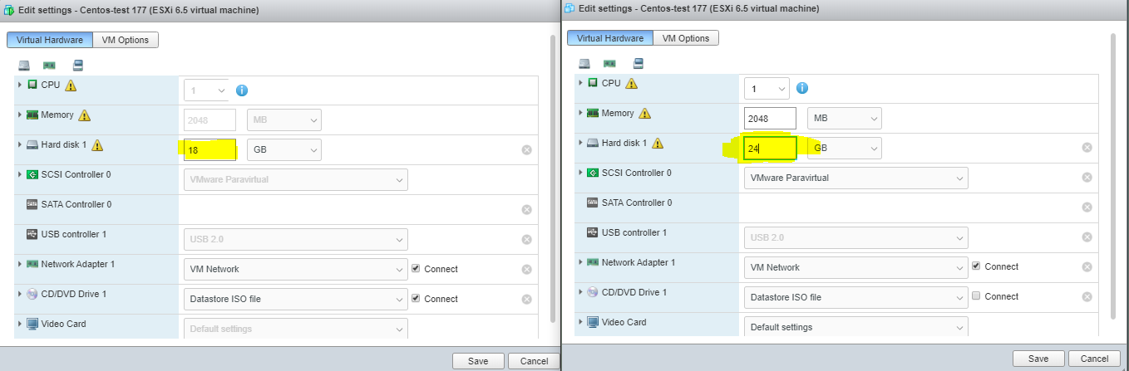

Step 3: Start the system and check the disk by typing the Following command**. fdisk -l**

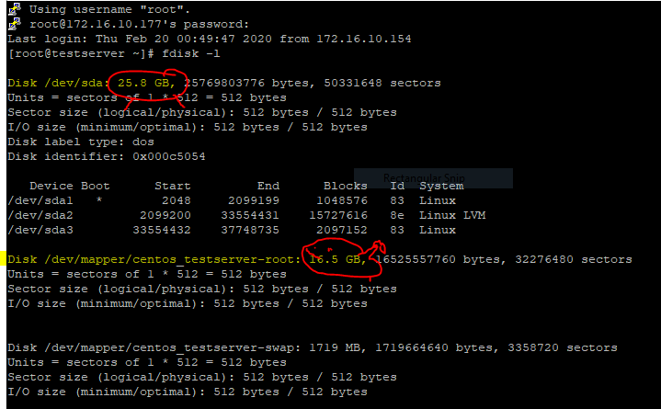

[Here we have 26GB but in our root partition show only 16 GB] so that we must create the unallocated space to allocated one.

Step4 :From The result of fdisk -l, Our extended memory lives in /dev/sda , so we have to create another partition from free space shown in /dev/sda

Fdisk /dev/sda

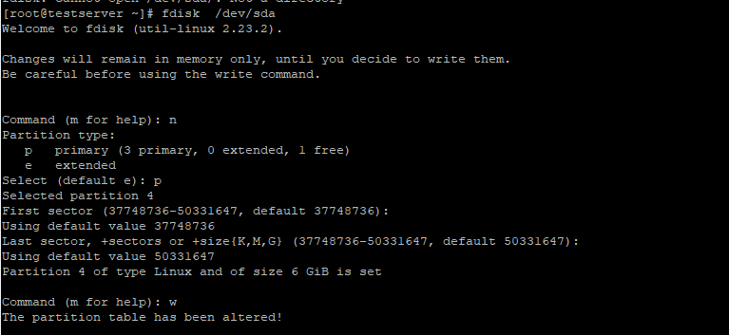

Step5**: partprobe** to show and save your partition and make the available for Physical volume creation.

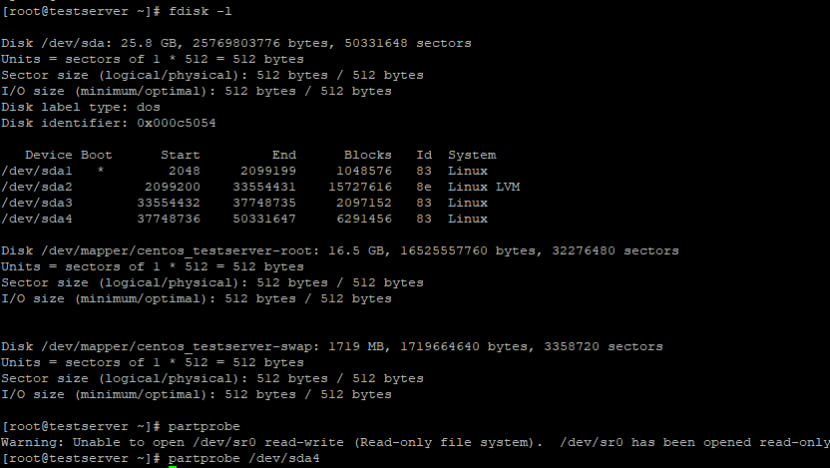

Step6:Now extend that volume to your volume group

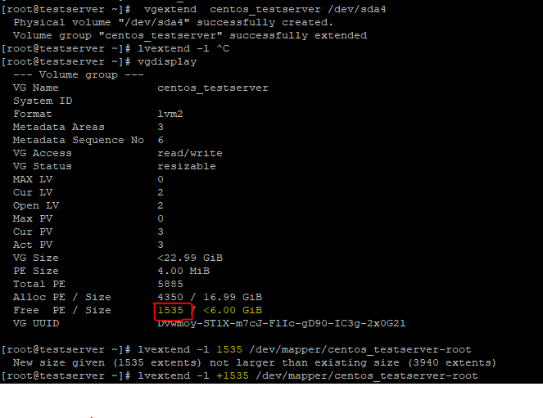

Now make available the partition in root directory

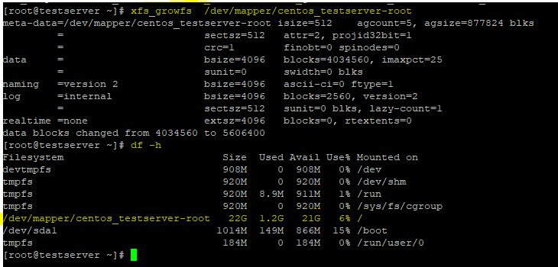

vgextend centos /dev/sda5

vgdisplay

partprobe /dev/sd3

vgextend /dev/sda5 centos

vgextend centos /dev/sda5

lvdisplay

lvextend -l +100%FREE /dev/centos/root

xfs_growfs /dev/centos/root

lvextend -l 100%FREE /dev/mapper/centos-root

xfs_growfs /dev/mapper/centos-root

df -h

vgdisplay

lvextend -l +6910 /dev/mapper/centos-root

xfs_growfs /dev/mapper/centos-root